Keeping your child safe from sexual abuse
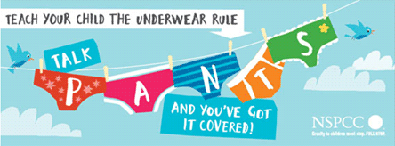
- The Underwear Rule - The Underwear Rule is a simple way that parents can help keep children safe from abuse - without using scary words or mentioning sex.
The NSPCC have developed a simple guide for parents to help parents talk PANTS with their child.
You can use the child-friendly version of PANTS guide when explaining the Underwear Rule to your child.

